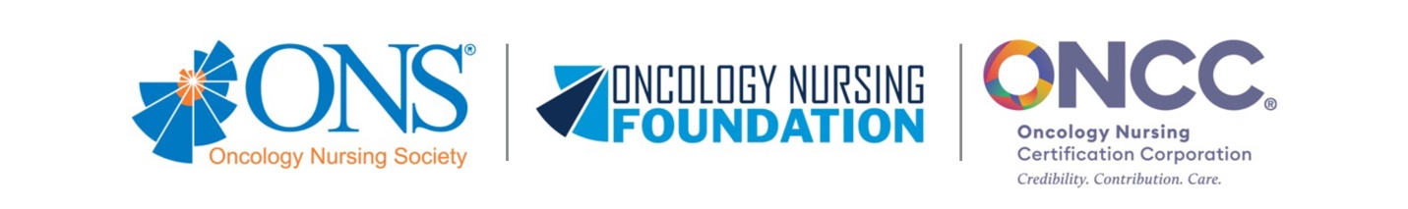Oncology Nursing History Center
Policies for Use of Collections
The Oncology Nursing History Center’s physical collections are open to all individuals. The materials are housed in environmentally controlled and secure stack areas and are made available for use onsite under the supervision of History Center staff.
All collections are non-circulating and are retrieved for researchers upon request.
What to bring
- Your laptop or notebook
- Current photo identification (driver’s license, staff badge, passport)
What not to bring
- Food or drink
- Pens (we provide pencils for taking notes)
- Scanners, tripods, or video equipment
Requesting and using materials
- Do not write on, mark, or alter the materials in any way.
- Staff will retrieve materials for you.
- One manuscript box or folder is permitted per table.
- All documents must always remain in folders in their original order; pull only one folder at a time from the manuscript box.
Other things to know
- All researchers must alert staff when they are leaving the premises and must return all requested materials to History Center staff.
- Researchers may be asked to submit for inspection any briefcase, laptop case, or any other parcel, book, notebook, or other personal property before leaving the premises.
- Some extremely fragile or unprocessed items may have access restrictions; other items may be inaccessible per the donor’s request.
Reproductions and permissions
- State or federal law may not permit the reproduction of some material.
  - Photocopies and scans are made solely for the researcher's convenience; they cannot be reproduced or transferred to any other person or institution without staff permission.
  - The use of cameras, cell phones, or tablets to photograph a limited amount of material is permissible if prior arrangements have been made with staff. Flash is prohibited. A permission form must be completed before taking any photographs. Further permission from the copyright holder may be necessary; especially for manuscript materials (see the copyright statements below).
Terms of access
Access and use of ONS's collections are subject to the Terms of Use.
Copyright information
Users of materials in the Oncology Nursing History Center collections must respect copyright and other legal rights held by other parties that may affect their subsequent use. The copyright law of the United States (Title 17) governs the making of reproductions of copyrighted material. Under certain conditions specified in the law, libraries and archives are authorized to furnish a reproduction. One of these specific conditions is that the reproduction is not to be used for any purpose other than your own private study, scholarship, or research. Any subsequent copying, downloading, or distributing materials accessed by you in the Oncology Nursing History Center’s physical and digital collections that are subject to copyright protection may constitute copyright infringement. In addition, the Oncology Nursing History Center may employ technical measures to prevent any further copying, downloading, or distribution of the materials. A violation of these terms may subject you to potential liability for copyright infringement.
The Oncology Nursing History Center collections may also contain materials that are not copyright protected and they may be used without restriction. Where material is copyright protected, you may have to seek permission from the rights holder to reproduce and otherwise use the materials. Alternatively, you may be able to use the exhibitions, digital collections, and the materials contained in them as permitted by law, such as under fair use or other copyright exceptions. The Oncology Nursing Society makes no representation about the copyright or other legal status of the materials. It is your responsibility to investigate and, if needed, clear the rights to use the materials.
The materials are displayed “as is” and without warranties of any kind, either express or implied, including any warranties of title, noninfringement of copyright, or other rights.
Note: Adapted from Columbia University Libraries.
- The WATCH list of copyright contacts is a useful place to begin searching for the estates of writers and artists.
- Cornell University Library has more general information about copyright and the public domain.

Updated March 2024

